**The Design of a Handyman Finder System**

Lindisipho Koyo, Shaheed Cloete, Minenhle Siyamukela Golden Ngwenya, Muhammad Yaasin Cole, Mawande Langa, Asiphiwe Hanjiwe & Amy Mitchell

Department of Information Technology

Cape Peninsula University of Technology

Cape Town, South Africa

214112322@mycput.ac.za, [213239442@mycput.ac.za](mailto:213239442@mycput.ac.za), [215285840@mycput.ac.za](mailto:215285840@mycput.ac.za), [218340869@mycput.ac.za](mailto:218340869@mycput.ac.za) , [219074054@mycput.ac.za](mailto:219074054@mycput.ac.za), [*218336675*@mycput.ac.za](mailto:218336675@mycput.ac.za) ,[214112322@mycput.ac.za](mailto:214112322@mycput.ac.za) & [219024979@mycput.ac.za](mailto:219024979@mycput.ac.za)

***Abstract***—***start writing the abstract here.***

***Keywords—keywords relevant to your paper such as big data, big data processing***

# **1. Introduction**

A handyman is an individual that is skilled at what is considered odd or specialized jobs (Betterteam Staff Writer, 2019). Motivaters like poverty, unsafe violent environments and the pursuit of better financial health causes rural-urban migration. (Hoffmann, 2019) Consequently, migration to urban areas causes a flood in job pursuits in the formal sector, to which many are unsuccessful, leaving millions of people having to resort to entrepreneurship in the informal sector (Ntshidi A.T, 2017) as a means to survival. The flood in job and housing pursuits is also known as urban congestion (Ntshidi A.T, 2017).

As economic prosperity increases in the world, people acquire more stuff (Mayeda, 2018) (Roser, n.d). In an article by Kasamani and Gikundi, who have created their own location-based handyman finder type mobile application, it states that there are several factors that are contributing to the growing need for handyman services, like having second homes, income/rental units and commercial properties that need maintenance and another being the increasing busyness of people's lives. Home or asset maintenance jobs are often jobs that require time, skill and expertise that takes years to acquire. As people become increasingly busy, the demand for domestic cleaning services increase. As people acquire more things the demand for tradespeople who can maintain and fix those things increase. An example being the smartphone industry producing many varieties and quantities of smartphones increasing the demand for service providers that are much more affordable than the original producers of that device.

The variety of specialized or odd services provided by tradespeople or handyman will always be relevant and in demand. Although finding, reviewing credentials and making sure that the service suits your budget is an arduous effort made by households every day. This effort is made strenuous when a situation arises that acquires immediate attending to by a professional (e.g. geyser leakage). Furthermore, the safety factor of inviting a stranger into your home environment is another concern that the users of these services must take into consideration. An example of this safety factor is a woman, after ordering transport for herself via a mobile application called Taxify, being put in a traumatizing unsafe environment and enclosed within a car where the driver exposed himself to her (News24 Staff Writer, 2018).

There is a balancing act of making a service more affordable by allowing informal providers to use a platform that makes use of that service and concurrently regulates the providers on the platform to ensure the safety of the users. This project recognizes, from a user perspective, the inconveniences of what goes into the process of finding handyman service providers. And by leveraging mobile technologies to streamline this process on behalf of households will benefit not only the national employment rate and national GDP, but too, heighten the quality of life of everyday households. With the problem of inconvenient and unsafe procurement of handyman services, the proposed problem solution aims to improve upon preexisting mobile technology solutions, by creating a mobile application that prioritizes an easy to use design and assists in fast and quality handyman service delivery.

**The research objectives are set as follows:**

1. To examine the shortcomings in preexisting digital solutions that attempt to resolve the problem, as discussed above.
2. To use the knowledge acquired in (i) to assist in developing a differentiated mobile solution used to connect households with safe and reliable handyman businesses.

**The research questions, too, are set as follows:**

1. How do preexisting applications, offering the same service, operate and what are the standard technical and non-technical mechanisms used to make such an application work?
2. How can we improve upon the pre-existing on-demand maintenance service applications available to South Africans, in terms of user-friendly design and technical innovation, in order to differentiate our product?

# **2. Background**

The third industrial revolution, known as The Digital Revolution, beginning its emergence in the mid-twentieth century, brought about an environment that economized the way in which technological devices could enhance the lives of everyday people. This third industrial revolution is characterized by the digital economy, which focuses on satisfying the everyday person’s needs or wants via virtual technologies.(Pouspourika, 2019)  A sub-category of the digital economy, here referred to as the on-demand economy, has economized expedition of service delivery and has thus changed the conventional expectations of the timeliness and immediacy of service delivery. This business model has been popularized and incorrectly dubbed The Uber Model, which many other on-demand service providers make use, doing so via mobile platforms. (King, 2016)

**2.1 Understanding the Relevancy of the Proposed On-Demand Handyman Finder App**

In a paper by Kasamani and Gikundi, it argues that locating handyman services is difficult when one relocates or travels to new areas since these service providers are situated across different areas and differ in costs, quality, and the type of service(s) that they provide (Kasamani and Gikundi, 2017). A common frustration when searching around for handymen services via the web is the lack of up-to-date information, and time spent surveying all the scattered locations in order to find a provider with a reasonable price. Having a service that connects a customer to a provider within the closest locality will arguably affect the pricing of service in favor of the client/user. A mobile handyman finder application provides convenience in terms of time, as well as in terms of the consumer budget.

As discussed above, as economic prosperity increases in the world, people need skilled handyman service providers to assist them in maintaining or fixing the multitude of things they frequently acquire. Home or asset maintenance jobs are jobs that require time, skill and expertise that the everyday person lacks. The proposed mobile application, consequential to the information gathered from this study, aims to collect and make available, in one centralized virtual space, the information of all handymen and women in and around South Africa. Beginning in Cape Town, and incrementally expanding this service nationwide, should business economics allow.

**2.2 Literature Review**

**Overview**

This subsection discusses the present state of the informal sector. It summarizes preexisting systems that streamline the process of finding handyman providers via mobile technologies. Also outlined are some system technologies that will be used to make the preexisting problem solutions.

**2.2.1 State of Informal Sector**

One in every six South African workers work in the formal sector. That is 2.5 million workers and business owners (Fourie, 2018). The entry of new informal business increases annually, and a common scholarly opinion is that the informal sector is a necessary tool that can be used to reduce poverty by creating more jobs in this sector, and thus sustaining livelihoods. (Fourie, 2018; Rogan & Skinner, 2019). According to Donna Rachelson, director of Seed Academy, factors associated with the success of small businesses include having a personal network (BizCommunity Staff Writer, 2019). Digital solutions as the one proposed by this research act as a personal network and is a tool that can be used to give small businesses a better chance of succeeding. Furthermore, the saturated business advertising environment does not allow for small businesses to make a noticeable presence to the inundated consumer (Kokemuller, n.d; Patel, 2019). Consumers rarely drive around their neighborhood to find a good or service they want or need. Instead the mobile computer, also known as a smartphone and networking technologies are used to acquire information of where those goods and services can be found. Which is why leveraging mobile technologies to provide a logically centralized platform for small businesses to get a chance at being seen in the saturated advertisement space is a benefit that can enrich the informal sector.

**2.2.2 Preexisting Problem Solutions**

**SweepSouth**

SweepSouth is a cleaning and maintenance service provider that allows users to book customized cleaning services whenever they need it using a mobile application. The domestic workers are signed up to the SweepSouth platform through a regulatory process and are paid between 80% and 96% of the booking fee which done in-app (SweepSouth Staff Writer, n.d). SweepSouth received over R50 million in venture capital in 2019 and the user-friendly app is used by many South Africans (VentureBurn, 2017). The specialization of this service is however limited to cleaning services only. SweepSouth Connect is sub-branch of the SweepSouth and a separate application that tries to make up for the recognized limitation to the service scope, allowing varying trades to be advertised (Malinga, 2020). Regulatory practices and limitation of service scope provides quality control, which is desirable for a startup. However, the problem solution proposed within this research study will be more inclusive to a variety of handyman services and this would mean that a regulatory process, if employed, will have to be relaxed to some degree. Furthermore, the SweepStar app does not have on-demand functionality, which the proposed problem solution will make use of in order to retain and gain more users. The on-demand functionality in maintenance/handyman applications is a feature appreciated by users (Espin, 2016).

**getTOD**

getTOD or Tradespeople on Demand is a mobile application that allows users to book maintenance services on demand. Once a booking is made, a hero (a term used for the platforms’ maintenance suppliers), responds and is on their way in +-1 minute (getTOD Staff Writer, n.d). All service providers are screened, and background checked before being able to make use of the platform (getTOD Staff Writer, n.d). A convenient and safe in-app payment system is used. The proposed problem solution will implement features like allowing a user to book services for multiple locations, a feature that getTOD have been criticized by users for not having (Google Play Store Reviews, n.d). And will leverage the applications public reviews to create an improved solution system.

**Handyman Direct**

Handyman Direct is a web-based application that allows households to post the maintenance job they require and the number of quotes they’d like to receive. The customer then receives a specified number of quotes and contacts the service provider of their choice. The quotes are free, as well as the service. The popularity of the service is uncertain. The proposed problem solution will not be web based, even though a web-based solution will increase the availability of the proposed service to more consumers. Building for mobile-based environments is more convenient as it allows households to access a service faster, as data retrieval happens faster due to the local file storage (Deshdeep, 2020). Despite web-based applications being more universal and platform independent, mobile apps help to increase user conversations, as people spend more time using mobile applications than browser-based apps (Newark-French, 2012) (see figure 2A).

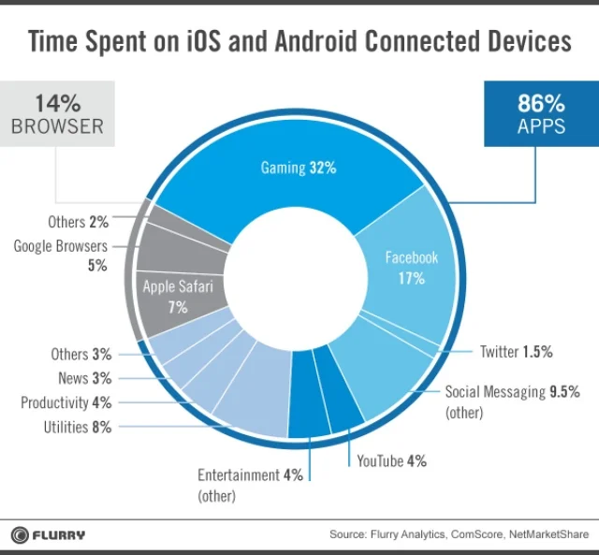

Figure 2A: Pie chart illustrating time spent on iOS and Android Connected Devices. (Source: Flurry Analytics, ComScore, NetMarketShare)

**2.3 System Technologies**

**2.3.1 Push Notifications**

A common feature of everyday mobile applications is push notifications. Push notifications are different to Short Messaging Services (SMS) in that it allows users to receive real-time notifications about activity that continues within the application while the user is not using it. Push notifications are popular to companies for just this reason as it motivates the user to return on using their applications, increasing engagement and user retention (Blair, n.d). Push notification services by Apple (APNs) were the first push notification service created (Airship Staff Writer, n.d) Each modern day mobile operating system has push notification services enabled and these APIs (application programming interface) are used by application developers within their apps. Messages/notifications sent to the users can be automated or be done manually. Messages can be personalized to users and can also be scheduled (Airship Staff Writer, n.d). An important part of advertising and the legalities thereof is giving the user a choice in opt in or out of receiving promotional notifications, which push notifications allow. Because SMS services don’t allow for these capabilities, minus the exception of the opting out feature, the proposed system will be making use of push notifications rather than SMS text messages.

**2.3.2 Android**

Android is an operating system created and owned by Google. The Android OS occupies majority of operating system market share, at 74.14%, and experts expect that market share to be maintained (Statcounter, n.d). The Android OS architecture is conceptually modeled as in Figure 2B, described as a software stack built on top of the Linux Kernel. The kernel being an operating system component that allows for communication between computer software and its hardware components (AfterAcademy Staff Writer, 2019). The Linux Kernel is used because of its security features and popularity (Android Developer Staff Writer, n.d).

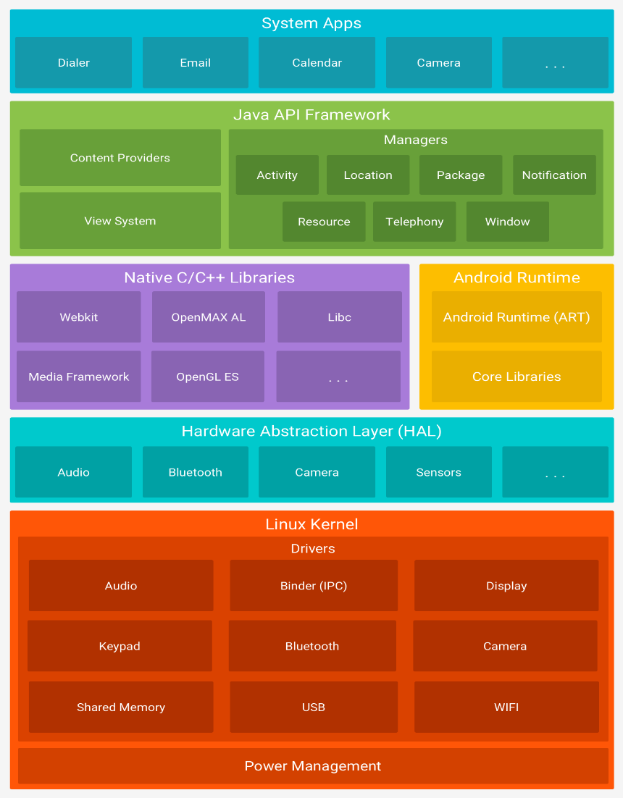Figure 2B: Android OS Software Stack. (Source: developer.android.com)

**2.3.3 SQL: Standard Query Language.**

The International Business Machines Corporation (IBM) and Multinational Technology company and Relation Software, Inc., which later became Oracle Corporation, both developed the standard query language (SQL) in the early 1970s. SQL is a computer programming language whose usages include database manipulation and maintenance. Due to the evolution of the language, greater commercial success was acquired by it in the 1980s, which led to it becoming an ANSI (American National Standards Institute) standard in 1986. As well as an ISO (International Organization for Standardization) standard in 1987. SQL has since increased with several more features. SQL usually is not adaptable across different database systems unless some adjustments have been made. This is due to each environment having its own dialect that’s not understood by others. Some environments can work together, and some can’t (Zelen, 2016).

# **3.1 Related Work**

We are living in a digital era where everything is mostly done with electronic devices. With just a click of a button you can request goods and services from the comfort of your home and brought to your doorstep in no time. We need to monitor other business competitors who are facing more opportunities every day due to rapid advancements in technology that comes with smartphones, tablets, and personal computers. This will drastically change how their services or product are delivered and accessed and are proved to be an imperative source of communication that have now become an integral part of our daily lives.

**3.1.1 Snupit**,

Snupit, South Africa’s top online marketplace, letting you quickly find and hire local service professionals. Over 2 million people per month use Snupit to locate good local maintenance workers for their desired service. The company was born upon realization that there is a demand for a fast and reliable online marketplace that can connect customers to service providers. In their App they show you the customer’s name, email, and phone number. You send your quote to the customer and can even phone the customer to get more details. They are very accommodative that they cater for both new handyman in the market and those who are already in the business but are just looking for extra work and extra cash.

**3.1.2. SweepSouth**

SweepSouth is currently one of the biggest competitors in the field. Established in December 2013, 74% of their workers are primary breadwinners at home. Of the thousands of people, they have given work opportunities to, 71% were previously unemployed, while 29% were underemployed. SweepSouth focuses on a range of fields from home cleaning to fixing and maintenance. They have also developed an application called connect, which expands upon just offering cleaning services and users are able to book their appointments and are able to do so on their website (SweepSouth.co.za).

With SweepSouth, users can select a service that they need by browsing through a list of vetted and reviewed professionals and are then are able to chat with them, pay them and setup a scheduled appointment through the app. The user can check to see every quote from the venders and choose which one would be the most affordable for your preference. They also use extensive background checks on interested professionals to ensure they meet the basic requirements, ensuring that the customers trust the professionals. SweepSouth uses a location-based system, where their website needs to be checked if its available in the area, you’re located in. SweepSouths shortfalls is that their application does not allow for cancellation or rebooking to different locations.

**3.1.3. Renovate-It**

[Kamal, Sania, Amirita, Eman, Areeba] have proposed an app along with a website that offers handyman services. This app or website is called Renovate-It. It is an android mobile app that uses features from Google Maps to show current location, distance, duration, and path between the user and the requested professional. The website’s backend uses php, JavaScript and the frontend are developed using html, CSS and bootstraps.

[Nana Abwna Sarpomaa Osei] has also proposed another version of a mobile application that assist users to locate shops/items and handyman. This mobile application has data of registered shops stored within a database, which will be retrieved when users search for items they want. Also, the app provides users with a platform for maintenance professionals, it has a database of these professional’s information and ratings given. Presenting users with options based on ratings when requesting services.

**3.1.4. HandymanDirect**

HandymanDirect is also designed in South Africa. Their strategy is that they only let really interested dealers contact you as to avoid a list of long calls which may eventually lead to disappointments and unwilling appointments. Once a service provider commits, the client is notified by email and receive the trader`s profile link. Their strength lies in the opportunity they give to their clients to read ratings and reviews from previous clients, which helps a potential client in getting to know the kind of person they will be dealing with a bit better before they start making appointments to quote. Their shortfall is that they only accommodate the qualified workers who are already registered by SARS. This might be a challenge for unqualified laborer’s who just provide their service using their innate skill but lack the related qualification.

This paper aims to improve on the areas where the above-mentioned Apps have lacked in order to win the existing competitors by offering the best communication service with the users, reduced costs and convenience. However, there are some good features that these apps represent and this paper aims to keep the same as those mentioned above by providing an opportunity to local maintenance workers to groom their business and having to mandate the service providers to provide their personal identifications to ensure authenticity and gain clients’ trust, the use of SQL databases, while making an improvement of making the Design of a Handyman Finder System, a more on-demand or immediate service app. Which means a maintenance professional will be sent to the user just minutes after being requested. Designing a simpler, user friendly version that anyone can use without any hassle regardless of their literacy level, social background, social class, and their age group will also be goal that will be achieved by this project.

# **System Architecture**

This section discusses the architecture of your artefact. State all the components of your artefact without attaching any technological tool to it.

This section also describes how the various components of your artefact/application interact to solve the intended problem.

Use subsection to highlight and discuss the components of your architecture. Subsections should be numbered 4.1, 4.2, 4.3,….and so on.

## Component one

Describe component one. Use good writing skills, employ the use of paragraphs and proper punctuations. Use short sentences that make sense instead of long sentences that confuse readers.

## Component two

Describe component two.

You can also use figures to demonstrate your points. Example of a figure is shown below. Make sure you reference your figures if you got it from some other resource.

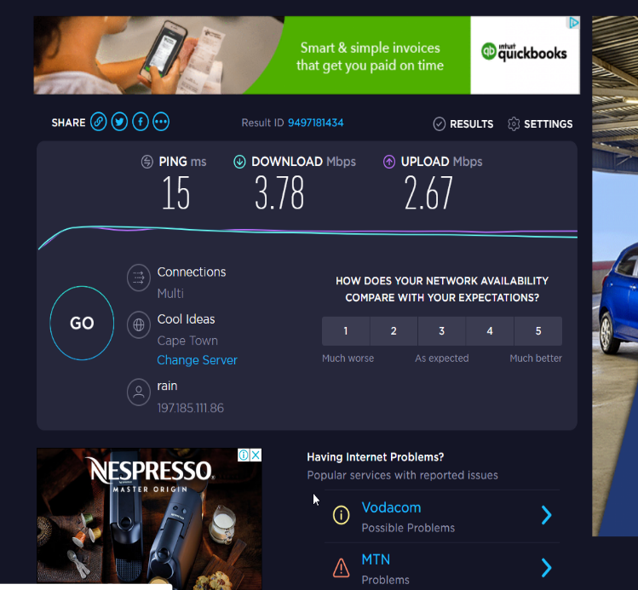

Fig. 4.1. Examples of figure with reference (Adams 2004: 23)

# **System Implementation**

This section describes the implementation of your artefact/application based on the system architecture described above.

Each component described in the architecture section should be implemented. The description of the implementation should contain the technologies and techniques used.

Use paragraphs again. Use subsections. Subsections should be 5.1, 5.2, 5.3,… and so on.

## Component one Implementation

Describe the implementation of component one.

## Component two Implementation

Describe implementation of component two.

Use diagrams, mathematical notation, formula, etc, if necessary.

# **Evaluation**

This section provided information on how the artefact/application was tested. Evaluation should be comprehensive. The test result(s) should be explained in details.

You can use subsection if required, to talk about the different stages of your evaluation. Subsections are 6.1, 6.2, 6.3,…and so on.

Tables and graphs are a good tool to present results from evaluations

## Computation Results

If you use subsection, this is an example of on.

Table 6.1. Example of a table to show results

|  |  |  |
| --- | --- | --- |
| Learning time for Manchester United (s) | Learning time for Chelsea (s) | Total Learning Time (s) |
| 0.48 | 0.994 | 1.474 |
| 0.416 | 0.537 | 0.993 |
| 0.383 | 0.534 | 0.917 |
| 0.503 | 0.878 | 1.381 |
| 0.581 | 0.757 | 1.338 |
| *Average learning time (s)* | | **1.2126** |

# **Conclusion**

The conclusion and advise for future work is discussed in this section. Conclusion should hightlight the importance of your artefact. This is shown in how well your artefact solves the problem.

This section also indicated areas of improvement on your paper.

# **Reference**

[1] Betterteam. 2019. *Handyman Job Description.* <https://www.wonolo.com/blog/what-is-the-on-demand-economy> [16 May 2019]

[2] Hoffmann E, Konerding V, Nautiyal S, Buerkert A. 2019. *Is the push-pull paradigm useful to explain rural-urban migration? A case study in Uttarakhand, India*. 14(4): (pages unknown) <https://www.ncbi.nlm.nih.gov/pmc/articles/PMC6445429/#:~:text=Rural%20push%20factors%20include%20poverty,discrimination%20in%20the%20cities%20%5B28%E2%80%93> [2 April 2019]

[3] Ntshidi A.T. 2017. *Patterns of Rural-Urban Migration in South Africa*  <http://repository.nwu.ac.za/bitstream/handle/10394/28123/Ntshidi_NA.pdf?sequence=1> [October 2017]

[4] Mayeda A. 2018. *The World Is Getting Richer. Some People Faster Than Others.* <https://www.bloomberg.com/news/articles/2018-01-30/the-world-is-getting-richer-some-people-faster-than-others> [30 Jan. 2018]

[5] Roser M. N.D (no date). *Economic Growth*. <https://ourworldindata.org/economic-growth> [n.d]

[6] Wonolo. 2018. *What Is the On-Demand Economy?* <https://www.wonolo.com/blog/what-is-the-on-demand-economy> [8 May 2018]

[7] News24 Staff Writer. 2018. *Taxify driver fired after 'exposing himself' to rider.* <https://www.news24.com/news24/video/southafrica/news/watch-taxify-driver-in-hot-water-after-exposing-genitalia-to-passenger-20180208> [8 Feb. 2018]

[8] Pouspourika K. 2019. *The 4 Industrial Revolutions*. <https://ied.eu/project-updates/the-4-industrial-revolutions/> [30 Jun. 2019]

[9] King S. 2016. *Uber Didn’t Create the On-Demand Economy, The On-Demand Economy Created Uber*. <https://smallbusiness.com/on-demand-economy/uber-on-demand-economy/> [4 May 2016]

[10] Kasamani BS, Gikundi D. 2017. *A Location-Based Service for Handyman Order Placement. Journal of Systems Integration*. 8(4): 29-41. <http://www.si-journal.org/index.php/JSI/article/viewFile/309/320> [2017]

[11] Fourie F. 2018. *The South African Informal Sector: Creating jobs, reducing poverty.* <https://www.hsrcpress.ac.za/books/the-south-african-informal-sector-providing-jobs-reducing-poverty> [March 2018]

[12] Rogan M, Skinner C. 2019. *South Africa’s informal sector creates jobs, but shouldn’t be romanticized*. <https://theconversation.com/south-africas-informal-sector-creates-jobs-but-shouldnt-be-romanticised-122745> [12 Sep. 2019]

[13] BizCommunity Staff Reporter. 2019. *What is the State of Entrepreneurship in South Africa?* <https://www.bizcommunity.com/Article/196/846/199161.html> [18 Dec. 2019]

[14] Kokemuller N. N.d (no date). *The Disadvantage of Market Saturation*. <https://smallbusiness.chron.com/disadvantage-market-saturation-69967.html> [n.d]

[15] Patel S. 2019. *Growing a Company in a Competitive or Saturated Market.* <https://sujanpatel.com/marketing/saturated-market/>[30 May 2019]

[1] SweepSouth Staff Writer. N.d (no date). *How much are SweepStars paid?* <https://help.sweepsouth.com/hc/en-us/articles/115005446709-How-much-are-SweepStars-paid-#:~:text=SweepStars%20do%20pay%20for%20their,that%20transport%20costs%20are%20minimized.&text=Tips%20are%20paid%20in%20full,SweepStars%20receive%20the%20full%20tip.> [n.d]

[16] VentureBurn Staff Reporter. 2019. *Cape Town startup SweepSouth raises over R50m in new funding round.* <https://ventureburn.com/2019/10/sweepsouth-raises-50m-round/> [7 Oct. 2019]

[17] Malinga S. 2020. *SweepSouth Connect links thousands to service providers*. <https://www.itweb.co.za/content/Olx4zMknEA3756km> [18 Jun. 2020]

[17] Espin C. 2016. *Ladies, the Uber of Handyman Services is finally here!* <https://www.womenstuff.co.za/hey-presto-review/> [5 Jul. 2016]

[18] GetTOD Staff Writer. N.d (no date). *How TOD Saves Your Day*. <https://www.gettod.com/> [n.d.]

Google Play Store Reviews. N.d (no date). *TOD*. <https://play.google.com/store/apps/details?id=com.gettod.gettod&hl=en_ZA> [n.d]

[19] Deshdeep N. 2020. *App or Website? 10 Reasons Why Apps are Better.* <https://vwo.com/blog/10-reasons-mobile-apps-are-better/#:~:text=So%20the%20mobile%20era%20is,the%20number%20of%20desktop%20users!&text=The%20choice%20between%20mobile%20apps,apps%20more%20than%20mobile%20websites> [4 Jun. 2020]

[1] Newark-French C. 2012. *Mobile App Usage Further Dominates Web, Spurred by Facebook*. <https://www.flurry.com/blog/post/113376825595/mobile-app-usage-further-dominates-web-spurred-by> [9 Jan. 2012]

[20] Blair I. N.d (no date). *What is a Push Notification? And Why It Matters?* <https://buildfire.com/what-is-a-push-notification/> [n.d]

[21] Airship Staff Writer. N.d (no date). *Push Notifications Explained*. <https://www.airship.com/resources/explainer/push-notifications-explained/#:~:text=A%20push%20notification%20is%20a,their%20devices%20to%20receive%20them>.[n.d.]

[22] Statcounter. N.d (no date). *Mobile Operating System Market Share Worldwide*. <https://gs.statcounter.com/os-market-share/mobile/worldwide> [n.d]

[23] AfterAcademy Staff Writer. 2019. *What is Kernel in Operating System and what are the various types of Kernel*? <https://afteracademy.com/blog/what-is-kernel-in-operating-system-and-what-are-the-various-types-of-kernel> [11 Nov 2019]

[24] Android Developer Staff Writer. N.d (no date). *Platform Architecture*. <https://developer.android.com/guide/platform> [n.d]

[25] Aldo Zelen. 2016. How to learn SQL: 6 Ideas for Newbies. Learn SQL.

<https://learnsql.com/blog/6-ways-can-learn-sql/> [13 December 2016]

[26] SweepSouth N.d (no date). Our Mission <https://sweepsouth.com/connect/>“SweepSouth - Our Mission. [Accessed 16 July 2020]

[27] Kamal Dharani, Sania Bhatti, Amirita Dewani, Eman Rajput, Areeba Ayaz. 2018. Renovate-It: A Geo-based Technical professional hiring system for repairing and maintenance services. <https://www.researchgate.net/profile/Sania_Bhatti/publication/324786107_Renovate-It_A_geo-based_technical_professional_hiring_system_for_repairing_and_maintenance_services/links/5cb6ccbc299bf120976ac955/Renovate-It-A-geo-based-technical-professional-hiring-system-for-repairing-and-maintenance-services.pdf>